

LjunggrenAudio RYO / Kymatica Devices 2xVCX
A dual VCA / Crossfader / 4QM
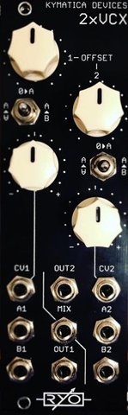
- dual VC Crossfader.
- dual hi-fidelity OTA-based modern VCA.
- dual Four Quadrant Multiplier (Ringmodulator / VC-polarizer).
- dual basic manual attenuator.
- All analogue circuitry.
- hi-fidelity signal chain with low noise opamps and OTAs.
- Buffered inputs and outputs.
- slim 8HP footprint.
- compact 40mm Depth (with power cable attached).
- low power draw: 34mA +12V / 32mA -12V / no +5V required.
- Works for audio as well as CV.
- Fast responding CV inputs allow for complex modulation and modulating with audio signals.
- sum mix output.
- ch1 output normalized to ch2 input for patching convenience.

downloads
* user manual
* quickstart guide
* assembly guide
* hi-res schematic
* datasheet
* BOM

